**Phase-3 Practice Project: Assisted Practice –**

**1. Create a project to demonstrate microservices with Spring Boot.**

# Step 1: Create a New Spring Boot Project in Spring Initializer

To create a new Spring Boot project. For this project choose the following things Project: Maven

Language: Java

Packaging: Jar

Java: 17

Please choose the following dependencies while creating the project.

Spring Boot DevTools

Spring Data JPA

MySQL Driver

Spring Web

# Step 2: Create Schema in MySQL Workbench and Put Some Sample Data

Go to your MySQL Workbench and create a schema named gfgmicroservicesdemo and inside that create a table called employee and put some sample data as shown in the below image. Here we have created 4 columns and put some sample data.

id

name email age

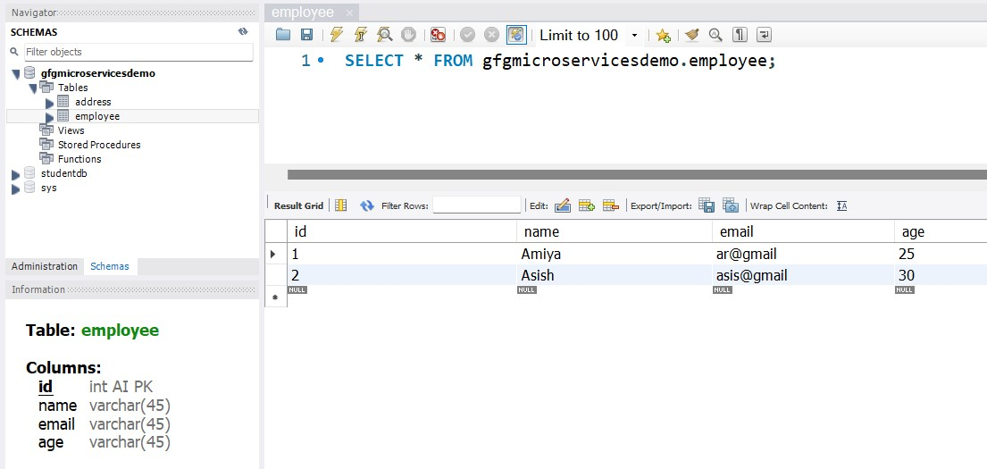

Now we are going to fetch Employee Data from Employee Table in our Spring Boot project. To do it refer to the following steps. Before moving to IntelliJ IDEA let’s have a look at the complete project structure for our Microservices.

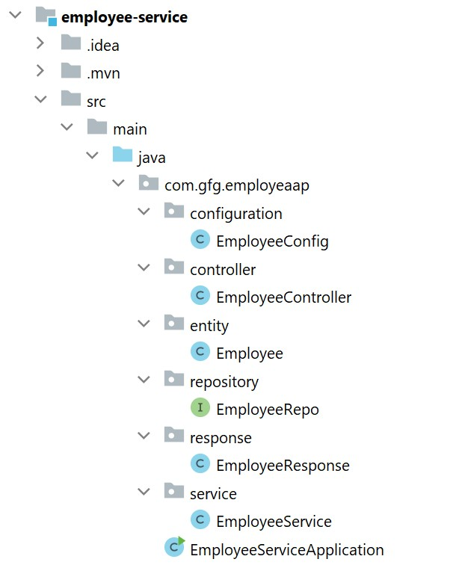

**Step 3: Make Changes in Your application.properties File** Now make the following changes in your[application.properties](https://www.geeksforgeeks.org/spring-boot-application-properties/)file.

spring.datasource.url=jdbc:mysql://localhost:3306/gfgmicroservicesdemospring.datasource.username=put your username here spring.datasource.password=put your password here

You may also refer to the below image

# Step 4: Create Your Entity/Model Class

Go to the src> main > java > entity and create a class Employee and put the below code. This is our model class.

|  |
| --- |
| importjakarta.persistence.*;  @Entity  @Table(name = "employee")  publicclass Employee {  @Id  @GeneratedValue(strategy = GenerationType.IDENTITY)  @Column(name = "id")  privateint id;  @Column(name = "name") private String name;  @Column(name = "email") private String email;  @Column(name = "age") private String age;  publicintgetId() { return id;  }  publicvoidsetId(int id) { this.id = id;  }  public String getName() { return name;  }  publicvoidsetName(String name) { this.name = name;  }  public String getEmail() { return email;  }  publicvoidsetEmail(String email) { this.email = email;  }  public String getAge() { return age;  }  publicvoidsetAge(String age) { |

this.age = age; }

}

# Step 5: Create Your Repository Interface

Go to the src> main > java > repository and create an interface EmployeeRepo and put the below code. This is our repository where we write code for all the database-related stuff.

|  |
| --- |
| publicclassEmployeeResponse {  privateintid; private String name; private String email;  private String age;  publicintgetId() { return id;  }  publicvoidsetId(int id) { this.id = id;  }  public String getName() { return name;  }  publicvoidsetName(String name) { this.name = name;  }  public String getEmail() { return email;  }  publicvoidsetEmail(String email) { |

importcom.gfg.employeaap.entity.Employee; importorg.springframework.data.jpa.repository.JpaRepository;

publicinterfaceEmployeeRepoextendsJpaRepository<Employee, Integer> {

}

**Step 6: Create an EmployeeResponse Class**

Go to the src> main > java > response and create a class EmployeeResponse and put the below code.

this.email = email;

}

public String getAge() { return age;

}

publicvoidsetAge(String age) { this.age = age; }

}

# Step 7: Create Your Service Class

Go to the src> main > java > service and create a class EmployeeService and put the below code.

|  |
| --- |
| Import com.gfg.employeaap.entity.Employee;  import com.gfg.employeaap.repository.EmployeeRepo;  import com.gfg.employeaap.response.EmployeeResponse;  import org.modelmapper.ModelMapper;  import org.springframework.beans.factory.annotation.Autowired;  import java.util.Optional;  public class EmployeeService {  @Autowired  Private EmployeeRepo employeeRepo;  @Autowired  Private ModelMapper mapper;  publicEmployeeResponsegetEmployeeById(int id) {  Optional<Employee> employee = employeeRepo.findById(id);  EmployeeResponseemployeeResponse = mapper.map(employee, EmployeeResponse.class); returnemployeeResponse;  }  } |

# Step 8: Create an Employee Controller

Go to the src> main > java > controller and create a class EmployeeController and put the below code. Here we are going to create an endpoint “*/employees/{id}*” to find an employee using id.

importcom.gfg.employeaap.response.EmployeeResponse; importcom.gfg.employeaap.service.EmployeeService; importorg.springframework.beans.factory.annotation.Autowired; importorg.springframework.http.HttpStatus; importorg.springframework.http.ResponseEntity; importorg.springframework.web.bind.annotation.GetMapping; importorg.springframework.web.bind.annotation.PathVariable; importorg.springframework.web.bind.annotation.RestController;

@RestControllerpublicclassEmployeeController {

@AutowiredprivateEmployeeServiceemployeeService;

@GetMapping("/employees/{id}")

privateResponseEntity<EmployeeResponse>getEmployeeDetails(@PathVariable("id") int id) {

EmployeeResponse employee = employeeService.getEmployeeById(id); returnResponseEntity.status(HttpStatus.OK).body(employee);

}

}

**Step 9: Create a Configuration Class**

Go to the src> main > java > configuration and create a class EmployeeConfig and put the below code.

mportcom.gfg.employeaap.service.EmployeeService; importorg.modelmapper.ModelMapper; importorg.springframework.context.annotation.Bean; importorg.springframework.context.annotation.Configuration;

@ConfigurationpublicclassEmployeeConfig {

@Bean

publicEmployeeServiceemployeeBean() { returnnewEmployeeService();

}

@Bean

publicModelMappermodelMapperBean() { returnnewModelMapper();

}

}

Before running the Microservice below is the complete **pom.xml** file. Please cross-verify if you have missed some dependencies.

|  |
| --- |
| <?xmlversion="1.0" encoding="UTF-8"?>  <projectxmlns=["http://maven.apache.org/POM/4.0.0"](http://maven.apache.org/POM/4.0.0)xmlns:xsi=["http://www.w3.org/2001/XMLSchema-instance"](http://www.w3.org/2001/XMLSchema-instance)xsi:schemaLocation="[http://maven.apache.org/POM/4.0.0](http://maven.apache.org/POM/4.0.0%C2%A0)[https://maven.apache.org/xsd/maven-4.0.0.xsd"](https://maven.apache.org/xsd/maven-4.0.0.xsd)>  <modelVersion>4.0.0</modelVersion>  <parent>  <groupId>org.springframework.boot</groupId>  <artifactId>spring-boot-starter-parent</artifactId>  <version>3.0.2</version>  <relativePath/><!-- lookup parent from repository -->  </parent>  <groupId>com.gfg.employeaap</groupId>  <artifactId>employee-service</artifactId>  <version>0.0.1-SNAPSHOT</version>  <name>employee-service</name>  <description>Employee Service</description>  <properties>  <java.version>17</java.version>  </properties>  <dependencies>  <dependency>  <groupId>org.springframework.boot</groupId>  <artifactId>spring-boot-starter-data-jpa</artifactId>  </dependency>  <dependency>  <groupId>org.springframework.boot</groupId>  <artifactId>spring-boot-starter-web</artifactId>  </dependency>  <dependency>  <groupId>org.springframework.boot</groupId>  <artifactId>spring-boot-devtools</artifactId>  <scope>runtime</scope>  <optional>true</optional>  </dependency>  <dependency>  <groupId>com.mysql</groupId>  <artifactId>mysql-connector-j</artifactId>  <scope>runtime</scope>  </dependency>  <dependency>  <groupId>org.springframework.boot</groupId>  <artifactId>spring-boot-starter-test</artifactId>  <scope>test</scope>  </dependency>  <dependency>  <groupId>org.modelmapper</groupId>  <artifactId>modelmapper</artifactId> |

# Step 10: Run Your Employee Microservice

To run your Employee Microservice src> main > java >EmployeeServiceApplication and click on the Run button. If everything goes well then you may see the following screen in your console. Please refer to the below image.

|  |
| --- |
| <version>3.1.1</version>  </dependency></dependencies>  <build>  <plugins>  <plugin>  <groupId>org.springframework.boot</groupId>  <artifactId>spring-boot-maven-plugin</artifactId></plugin>  </plugins></build>  </project> |

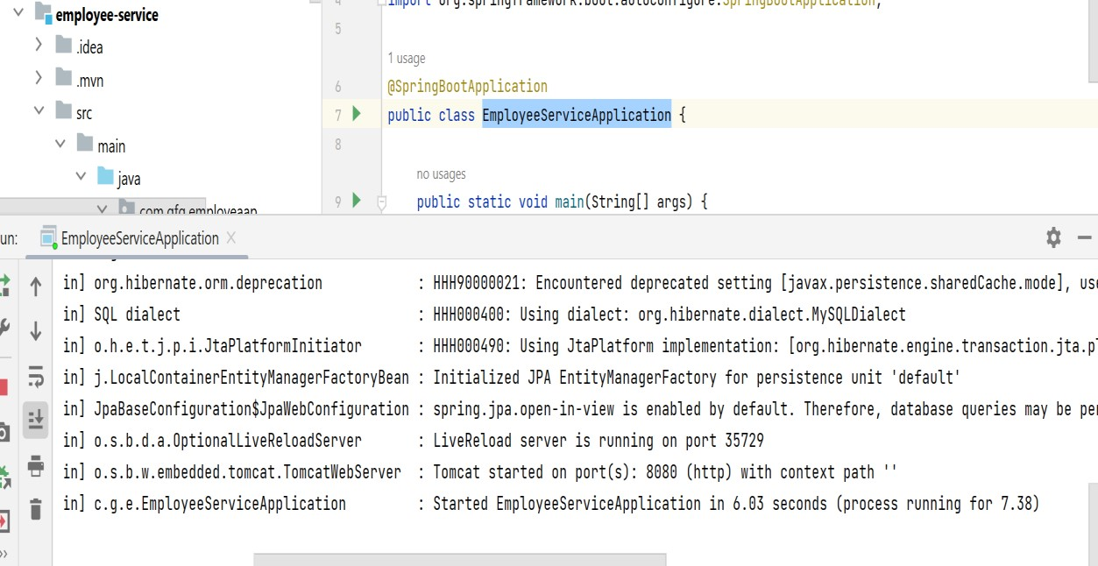

# Step 11: Test Your Endpoint in Postman

Now open Postman and hit the following URL

GET: http://localhost:8080/employees/1

And you can see the following response

{

"id": 1,

"name": "Amiya",

"email": "ar@gmail",

"age": "25"

}

Please refer to the below image.

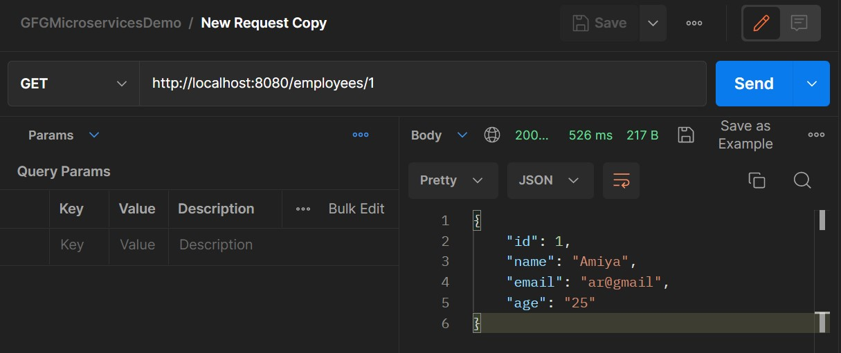

This is how we have built our Employee Microservice with the help of Java and Spring Boot. And you can also design all your endpoints and write all the business logic, database logic, etc in the corresponding files.